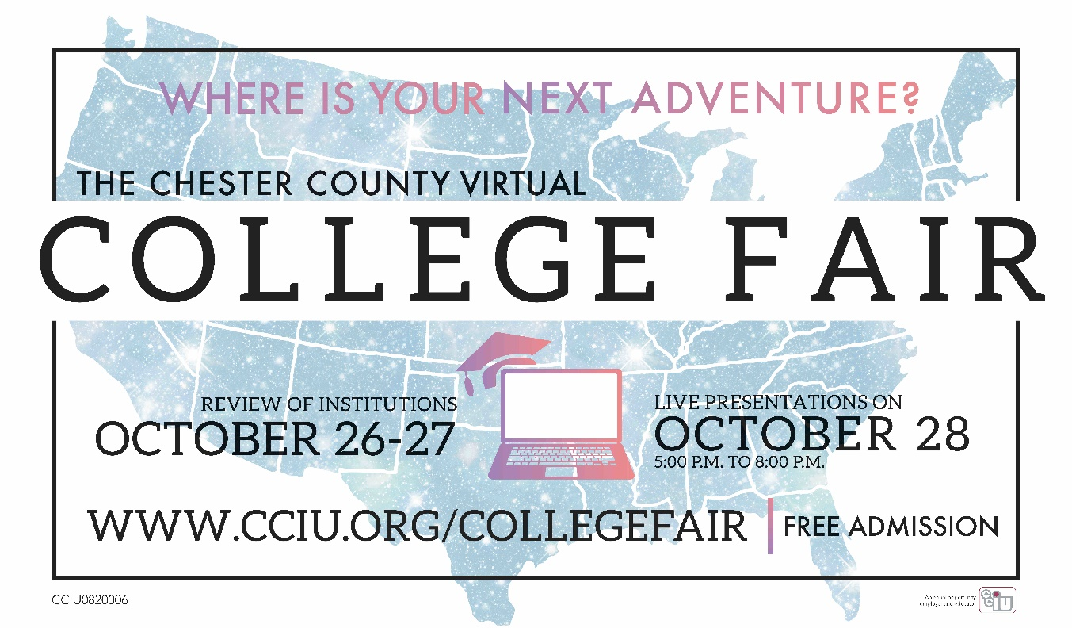

Representatives from 230+ colleges nationwide have the opportunity to meet with high school students and their parents at Chester County Virtual College Fair, which is hosted by the Chester County Intermediate Unit.

This year's fair will be powered by [VisitDays](https://visitdays.com/), a user-friendly platform that provides intuitive, informative, interactive and fun virtual experiences. Prior to the event, attendees will be able to create their itinerary by selecting the live or one-on-one session(s) they wish to attend. More Information about setting up your VisitDays account and how to schedule a session(s) with your college/university of choice will be available in the near future.

Attending the fair provides career readiness opportunities for students by ensuring that they have access to career exploration and preparation activities that are standards-aligned and evidence-based. This includes the development of career plans and portfolios that help students identify pathways and opportunities for postsecondary success.

**\*\*Students may preview institutions from October 26-28. Colleges will be "live" on Wednesday, October 28 from 5:00 to 8:00 p.m. For up-to-date information and to receive notification that our fair is now open, please sign up for our mailing list** [**here**](https://forms.gle/vRFdqF787znm9T6y8)**. If you have any questions, contact collegefair@cciu.org!**